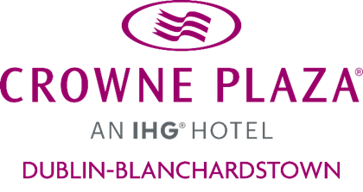

Crowne Plaza Dublin-Blanchardstown

Sustainability Policy 2022

1. Organization Ethos
At Crowne Plaza Blanchardstown we are committed to protecting the environment for future generations
We aim to:
- Be a responsible company by having a sustainability policy in place
- Help protect our environment for future generations
- Reduce carbon emissions
- Conserve energy
- Use local produce (Ireland) and in season products, buy Irish & locally sourced produce where possible
- Reduce energy consumption
- Adopt a 0-single-use-plastic policy where possible
- Reduce, Reuse, Recycle policy to be promoted
- Strive for continuous improvement through setting objectives, targets & KPI’s
- Ensure a Green team is in place
- Communicate & promote environmental awareness among all our team members
- Become more involved in the local community
- Comply with all applicable environmental Legislation.

2. UNWTO Definition
- At Crowne Plaza Blanchardstown, we believe that sustainable tourism is tourism that takes full account of its current and future economic, social, and environmental impacts while addressing the needs of visitors, the industry, the environment, and host communities (UNWTO, n.d.). We therefore aim to reduce our negative effects and increase our positive impacts.

3. Continuous Improvement
- We know we have a lot to do, and this is just the start, but we are working hard in the background and we are committed to continuously striving to be industry leaders in sustainability.

4. Measuring and Reducing Negative Impacts

4. A. Energy Consumption

We commit to measuring our electricity consumption every week and do the following to reduce consumption by 5% over 12 months
- Switch off appliances when not in use
- Replacing lightbulbs with LED Bulbs and by introducing additional PIR sensors in all suitable locations
- Install alarms on fridges and freezers so as to enhance awareness when doors being left open
- Reintroduce “energy goblin” – designated person who does a walk around the hotel to review energy usage
- Educate all team members on the conservation of energy & ensure that all appliances are switched off when not in use.
- Promotion of IHG “Green engage” program within the hotel
- Use of sub-meters once installed within the next 12 months
- Better use of smart building controls through BMS lowering electricity and gas consumption.
- Purchase new appliances with highest efficiency rating when old appliances are being replaced.
- Air conditioning timed to operate in offices during working hours only.
- PIR sensors in place in all relevant areas.

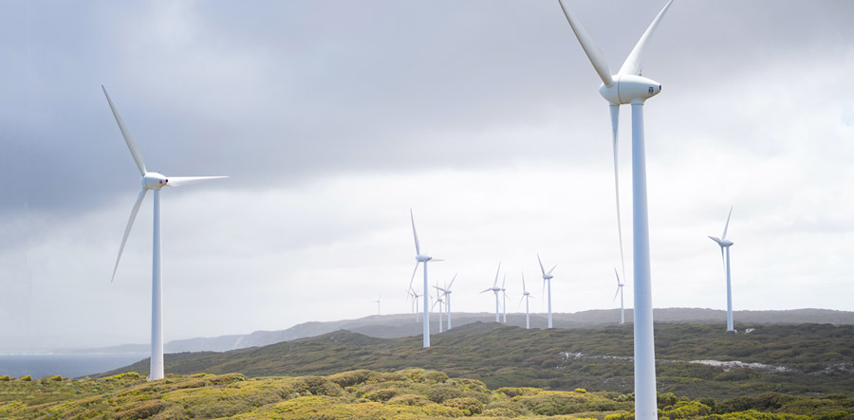

4. B. Water Consumption

As part of our commitment, we aim to reduce our water consumption by 10% in 12 months by:
- Reduce, reuse, re-educate water policy for guests
- Reduce, reuse, re-educate water policy for team members
- Provide written material on how to conserve water for guests & team members
- Target of under 416 liters per guest night
- Implement the use of tools to minimize the quantities of water used in toilet flushes, showers etc. where possible.
- Continue to conserve linen through linen re-use program.
- Implement Recycled glass water bottles into all meeting rooms
- Eliminate the use of plastic bottles in meeting rooms
- Remove Wok station with continuous water flow
- Purchasing Eco friendly equipment, air conditioner units, dishwasher, ovens etc.
- Using environmentally friendly cleaning products

Timeframe: Within 12 months

4. C. Waste Production
We commit to measuring our waste consumption every month and do the following to reduce consumption in 12 months’ time by:
- Ensure Reduce, Reuse and Recycle policy is in place
- Increase percentage of waste recycled by 3% over the year
- Evaluate all purchases (pre cycling) & ensure items delivered in reusable packaging/containers where possible
- Committed to using non disposables only where possible
- Educate hotel guests on how to recycle properly
- Educate our team members on recycling best practices
- Focus on the reduction of food waste, compost, increase seasonality of food produce where possible
- Change to bulk guest toiletries savings tonnes of plastic each year
- Use water dispensers and refillable bottles in Conference and Event
- Cleaning agents are selected based on low environmental impact from Ecolab
- Introducing recycling bins in all bedrooms and meeting rooms & public areas
- Replace plastic coaster & plastic wrappers on robes / slippers / biscuits
- Minimizing stock orders to avoid out of date issues and wastage
- Better portion control

Timeframe: Within 12 months

5. Supporting Biodiversity

To protect and conserve our local biodiversity we:
- Become part of Crann and work with them on tree planting projects.
- Use only Ecolab chemicals which protect biodiversity.
- Join the All-Ireland Pollinator Plan & implement one activity – plant wildflower garden at the side of the hotel.

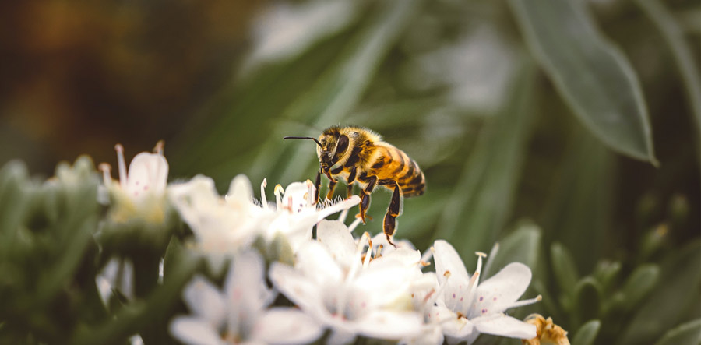
Timeframe: Within 12 months

6. Ethical Purchasing
At Crowne Plaza Blanchardstown we want to establish a baseline of what we are doing:

- When purchasing goods, we ensure that we favour Irish sourced products where possible.
- We commit to reducing, reusing & recycling packaging.
- Buy products in bulk reusable containers/packaging where possible to reduce the amount of packaging & energy used in deliveries.
- Contact suppliers to review current list & establish what items may be substituted for a Fairtrade product where possible.

7. Carbon Management
At The Crowne Plaza Hotel Blanchardstown we are committed to measuring & reducing our carbon footprint as much as possible & locating an offset partner within the next 12 months, while working on developing a reduction plan:
- Utilizing the business calculator to establish CP Blanchardstown carbon footprint.
- Using energy efficient light bulbs.
- Reducing, Reusing, Recycling policy in place.
- Educating team members on reducing our carbon footprint.
- Linen reuse program, cutting down linen changes further.
- Ensuring Green team is in place.
- Introduce QR codes on the tables for the Bar menu and in bedrooms for Room service menu, instead of printing.
- Introducing more plant-based menu options.

Timeframe: Within 12 months
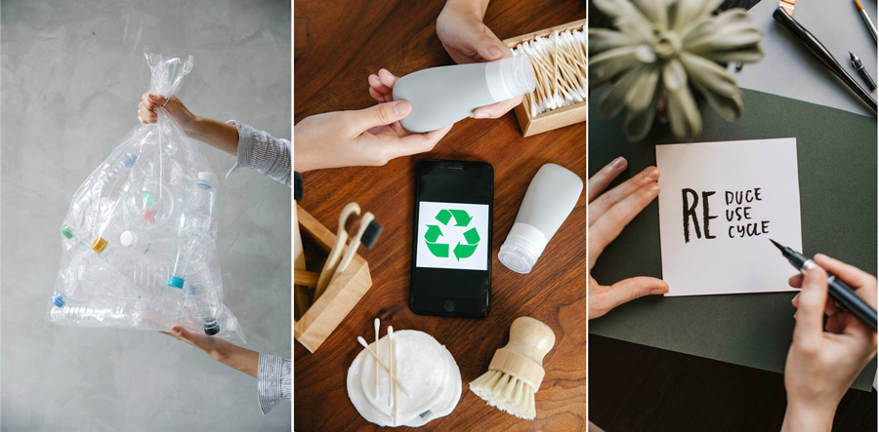

8. Meeting & Events

We aim at limiting the environmental impact of our meetings and events by following meeting & event guidelines.
We are aware that travelling to meetings and events has a large impact on the environment, we therefore commit to online internal meetings where possible.
As part of our commitment, we will:
- Adopt a 0-single use plastic policy where possible in all conference facilities.
- Nominate green angels for large conference events.
- Participate in Cycle to Work Scheme.
- Electric vehicle chargers to be installed where possible.
- Share sustainability policy with Conference Bookers.
Timeframe: Within 12 months

9. Responsible Sustainability Marketing
We know we can’t always get things right the first time. We therefore commit to honestly communicating where we are on our journey and our improvements.
We commit to:
- Educate our team on the sustainability policy & where we are on the journey.
- Educate team members on the risk of green washing.
- Ensure that the marketing message is honest & accurate.
- Implement marketing guidelines provided by Head Office.

10. Stakeholder Engagement
Our stakeholders, such as our customers, team members, community, and suppliers are important to us, we aim to welcome their views by ensuring that we have an open-door policy for communication where everyone has the opportunity to raise their concerns and share their ideas on an ongoing basis. As part of our commitment, we will utilize the following methods of communication:

- Site inspections
- Social media
- Customer feedback surveys
- Online meetings
Timeframe: Within 12 months

11. Social Responsibility

We will support our local community by:
- Supporting charities - a new charity is selected each year
- Yearly activity such as a beach cleanup.
- Gift local products to our international corporate guests on departure.
- Donation of vouchers to local groups to help raise money for their charity.
- Offering work experience in cooperation with Down Syndrome Ireland
Timeframe: Within 12 months

12. Further Guiding Principles

Further guiding principles we adhere to are:
- Tifco Human Rights Policy
- Tifco Anti-Bribery & Corruption policy
- Fairtrade – The sourcing & purchase of Fairtrade products where possible

